DAD 220 Module Four Lab Template

Overview

Begin by doing the following steps in the IDE (Codio):

- Load the classicmodels data set.
- Start a new terminal session and run this command: mysqlsampledatabase.sql
- Write commands to use the classicmodels database and show its tables to verify that you are in the right place.

Then perform the steps below to complete the lab. Manually enter any commands you are asked to write. At the end of each step, replace the bracketed text in this template with your screenshot, response, or both, as indicated. Submit your completed template for grading and feedback. Screenshots should be sized to about one-quarter of a page. Written responses should be in complete sentences. Rename this document by adding your last name to the file name before you submit it.

Identify Cardinality and Table Relationships

- Retrieve employee tuples and identify the number of employees in San Francisco and New York.
  - Command for San Francisco: select firstName, lastName, jobTitle, offices.city from employees inner join offices on employees.officeCode = offices.officeCode where state = 'CA'.
  - Write and run a command to return records from New York on your own.
  - Validate the completion of this step with a screenshot of these two tables.

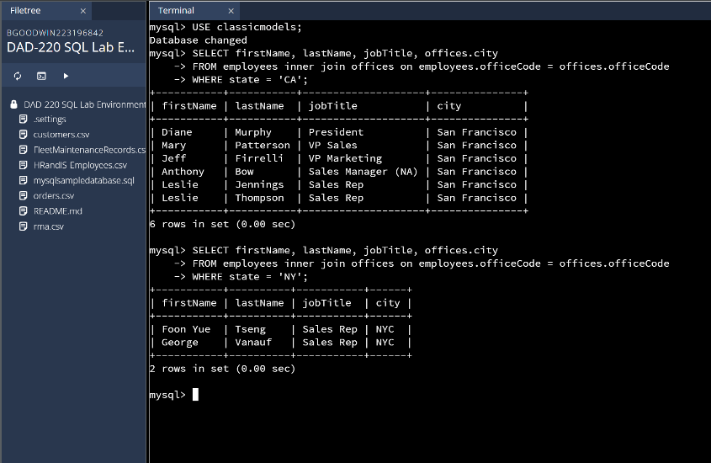
- Retrieve order details for orderNumber 10330, 10338, and 10194 and identify what type of cardinality this represents in the entity relationship model.
  - Retrieve the order details by running SELECT queries with WHERE clauses against the Orders table.

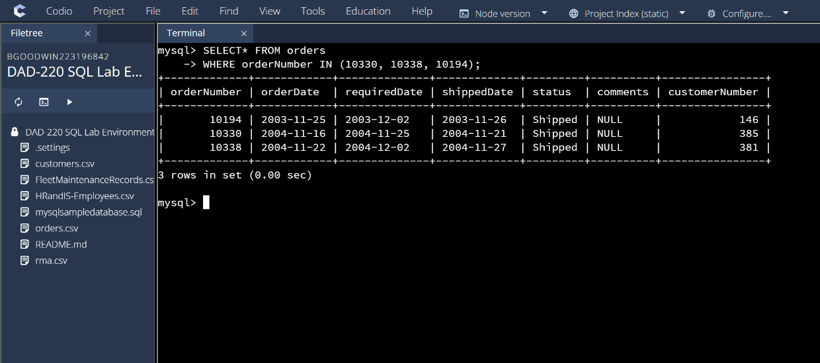
  - Now, identify what type of cardinality this represents in the entity relationship model.

The cardinality for this entity relationship model would be one-to-one because each customer gets exactly one order despite this size of it.

- Delete records from the payments table where the customer number equals 103.
  - Run a DESCRIBE statement to identify fields in the Payments table first. You are creating a file with any name you choose.
  - Select the records from the Payments table for customer number 103 before deleting them.

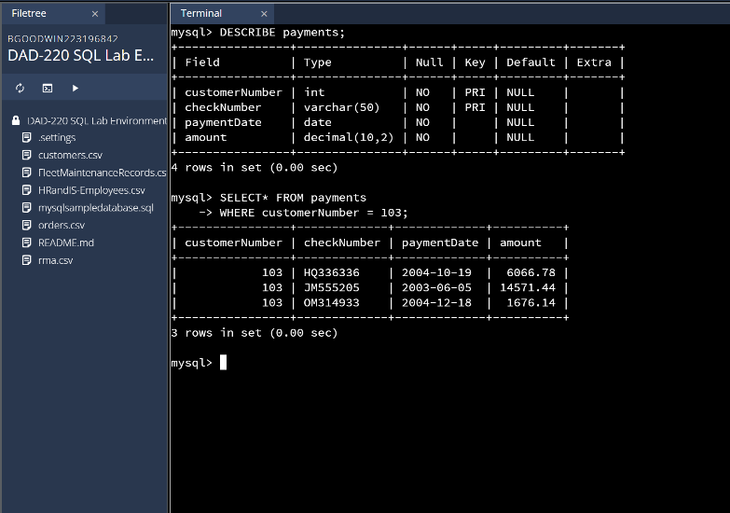
  - Delete the records from the Payments table for customer number 103.
  - Run a SELECT statement against the table to show that customer number 103 is no longer there.

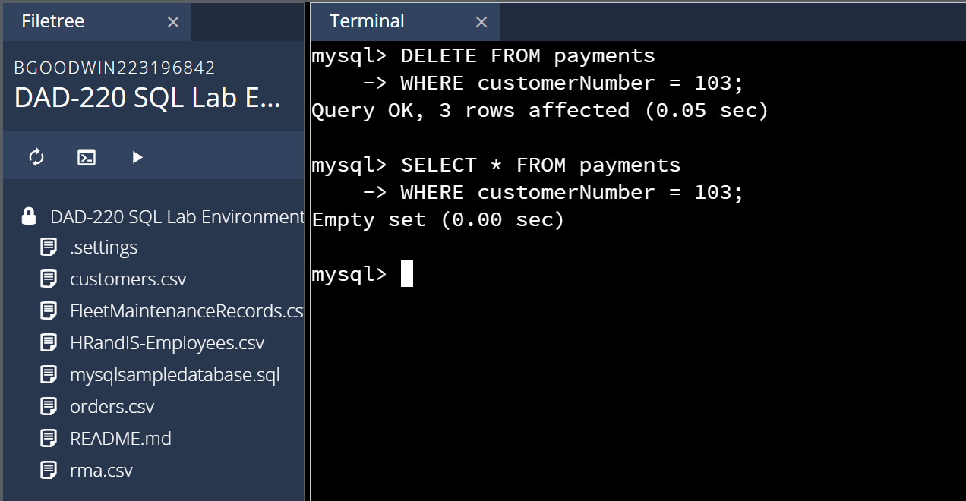
- Retrieve customer records for sales representative Barry Jones and identify if the relationships are one-to-one or one-to-many.
  - Remember: SELECT, FROM, INNER JOIN, and WHERE.
  - Use Barry’s employeeNumber, 1504, and perform a join between the customer salesRepEmployeeNumber to retrieve these records.
    - Identify whether these entities demonstrate one-to-one or many-to-many relationships.

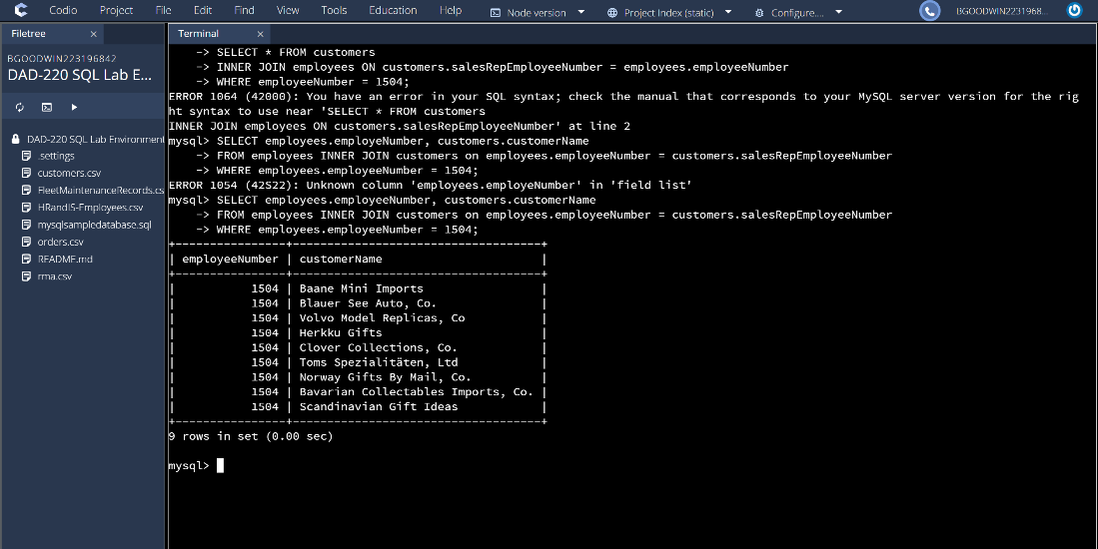
This is a one-to-many relationship as there is one salesman working with many different costumers which shows the one-to-many aspect of cardinality.

- Retrieve records for customers who reside in Massachusetts and identify their sales rep and the relationship of entities. Identify if these entities demonstrate one-to-one or many-to-many relationships.
  - Remember: SELECT, FROM, INNER JOIN, and WHERE.
  - Use employee.firstName and employee.lastName in your command.
  - Identify whether these entities demonstrate one-to-one or many-to-many relationships or one-to-many.

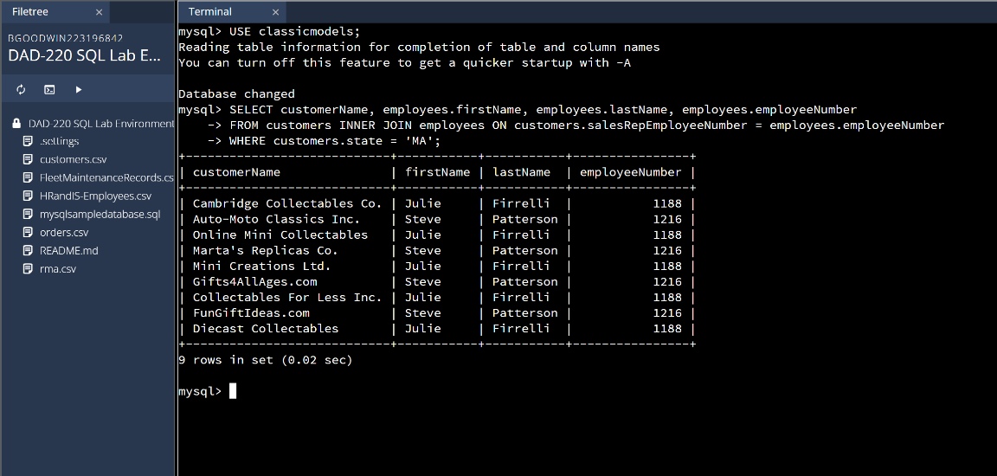
The relationship between these items is one-to-many because all of the information from service rep to customer can be connected to one entity which is the state they are from.

- Add one customer record with your last name using an INSERT statement. You may use the name of a celebrity or fictional character if you don’t use your own name.

  - You may use the name of a celebrity or fictional character if you don’t use your own name. Think of this as your signature.
  - Complete these actions to get to the right place to enter this information: (1) Show databases, (2) use classicmodels, (3) show tables, (4) describe customers;
    - You should now see all of the fields that you’ll need to fill in to complete this step.
    - Reference your Module Two lab or resources on how to populate these fields if you need to.
    - Populate the following fields:

customerNumber
customerName
contactLastName
contactFirstName
phone
addressLine1
addressLine2
city
state
postalCode
country
salesRepEmployeeNumber
creditLimit

    - Run a SELECT statement on the Customers table and capture it in a screenshot.

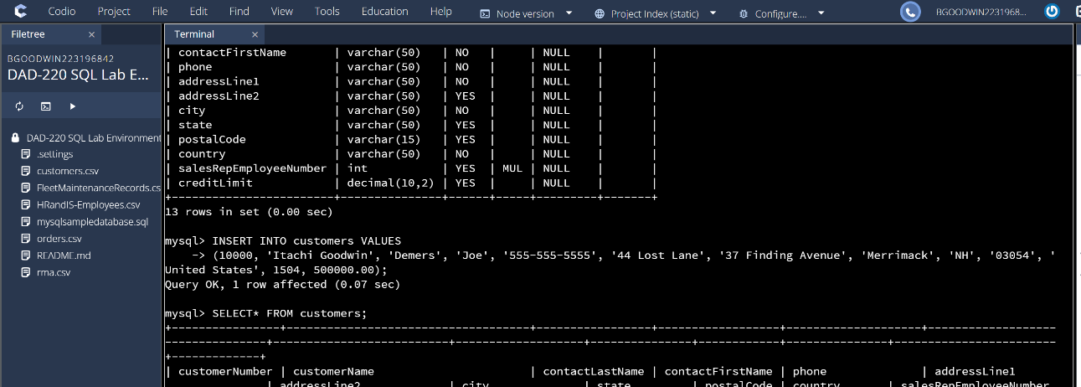
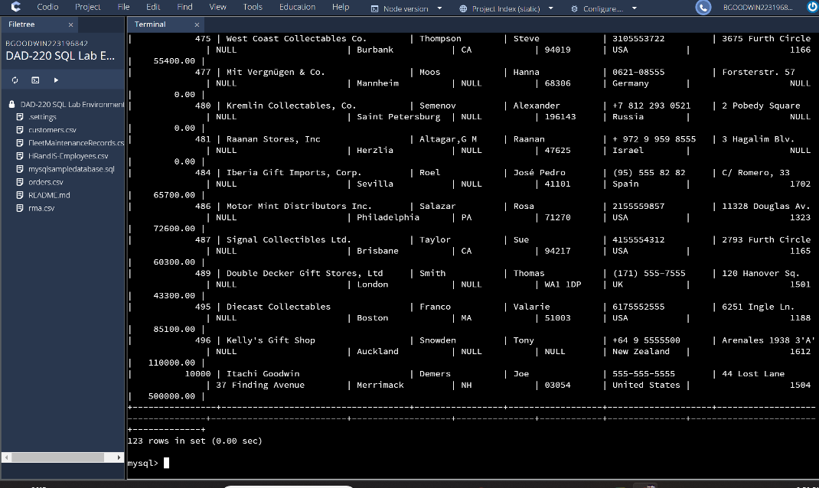

- Reflection: Use the lab environment or the screenshots you’ve worked with for this step. Address the prompts below in your reflection. Write a paragraph in response to each prompt:
  - Define how cardinality is applied to the databases you’ve been working with. Explain why different numbers of records were returned from the different offices.

Cardinality is important because it shows the relationships between how different tables not only relate but interact with each other in a database. It helps to define the rules in which databases operate or relate to each other so you can follow the information that is between tables. Charts can be created that show how each table within a database not only connects but also relates to the information. It can also point out unique values in tables.

  - Compare and contrast the different queries you ran and how cardinality applies to them.

The type of relationship that is returned in both instances was a one- to – many as there was always one thread of information that connected to different components of the different tables. The state was the one that connected not only the customer but also the sales rep as well. For the other example it was the sales rep that was connected to many different customers. The first example is different because specifically one customer is connected with one packages.
The one – to – one relationship shows that there is only one order number for the order being received.

  - Describe two of the crucial benefits of cardinality in this type of database.

The first crucial benefit is that it helps with database design as it shows the relationship between the tables along with how that data is connected. It also shows the number of unique values that are present in the database.

